#1 The original site I chose to critique was Thredup, an online consignment store. I also critiqued another site because for some reason Thredup will not give you the file size for their merchandise. So here is my original write up on Thredup along with another write-up. The use of images for this site is vital because it is a clothing store. Customers want to see what they are buying and images provide a look at the pants, skirts, dresses and more before purchasing. With that being said there was still quite a bit of color even after removing the pictures, which I found different from a lot of other sites. This helped add some interest to the site. Other sites I looked at often had just rows upon rows of text if the images were removed. There was still enough words on the Thredup site that even without images I could get the general idea of what sort of sales were going on and for what items. Also when you scrolled over the space where there used to be a picture of individual articles it would tell you the style of clothing and what size it was. Even with the images gone I still found the site was still pretty easy to navigate.
There was 38 images used on the home page for Thredup.
While I don’t know why you would shop for clothes with images turned off, if you were going to do it I feel this site would be easy enough to navigate and still provide some interest. I feel the images are used successfully. There is not a lot of unnecessary ones, but they definitely put their wares out there for potential customers to see.

https://www.thredup.com/

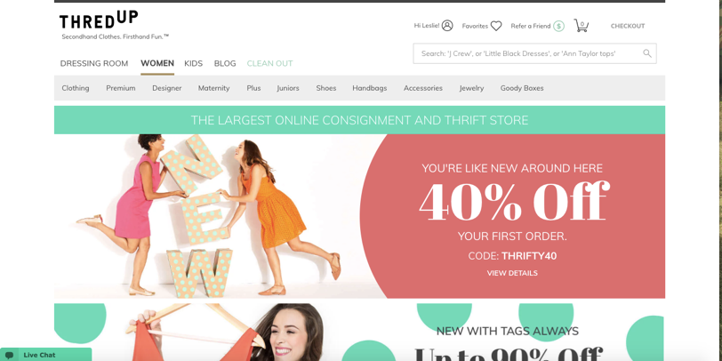
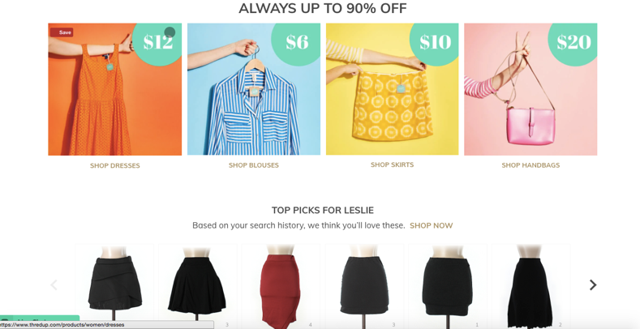
The Modest Poppy https://themodestpoppy.com/
This site was definitely a little more antiquated. When images were disabled there was basically nothing left to the site. This definitely shows that their site is not set up for people who might wish to disable images. As you clicked around on some of their different tabs and such there was a little more information without the pictures such as what the article of clothing was and the price. This site was definitely nowhere close to as good as Thredup and would be very hard to navigate without pictures. Their home page has 22 images and all the image files take up 537.95 kb of space.
